

DEPARTMENT OF COMPUTER ENGINEERING

MINI PROJECT REPORT

A report submitted in partial fulfillment of the requirementsfor the Award Degree of

BACHELOR OF ENGINEERING

in

COMPUTER SCIENCE

By

Aniket Bidgar (21C0026)

Under Supervision of

Prof.S.F.Sayyad

Academic Year: 2023-24(Term-II)

Savitribai Phule Pune University





DEPARTMENT OF COMPUTER ENGINEERING

CERTIFICATE

This is to certify that Aniket Bidgar (21C0026) from Third Year Computer Engineering has successfully completed his work titled" Web Technology Mini Project Report" AISSMS College of Engineering, Pune in the partial fulfilment of the Bachelor's Degree in Engineering.

Project Guide

Prof. S. F. Sayyad

Head of the Department

S. V. Athawale

Principal

Dr. D. S. Bormane

**Index**

|  |  |  |
| --- | --- | --- |
| Sr. No. | Topic Name | Page No |
| 1. | Acknowledgement | 4 |
| 2. | Abstract | 5 |
| 3. | Introduction | 6 |
| 4. | Problem Statement | 7 |
| 6. | System Requirements | 8 |
| 7. | website (Overview) | 9 |
| 8. | Implementation | 10 |
| 10. | Functionality and Advantages | 15 |
| 11. | Conclusion | 17 |
| 12. | References | 18 |

**ACKNOWLEDGEMENT**

The satisfaction that accompanies the successful completion of this review would be incomplete without mentioning the people who made it possible. Without their constant guidance and encouragement, our efforts might have been in vain. We consider ourselves privileged to express our gratitude and respect to all those who guided us through the completion of this project.

We would like to thank Dr. S. F. Sayyad, our project guide from the Third Year Engineering Department, for his encouragement, constant support, and guidance, which were invaluable in helping us complete this first stage successfully.

Additionally, we appreciate the opportunity given to us by our Head of Department, Prof. S. V. Athawale, our Principal, Dr. D. S. Bormane, as well as all the teaching and non teaching staff of the Computer Department who were directly or indirectly involved in our project.

**ABSTRACT**

This mini project report describes the development of an online exam system created as part of an academic curriculum. The project aimed to design a secure and user friendly platform for conducting online exams with instant results. The report outlines the project’s objectives, methodologies, technologies used, and the outcomes achieved. The project began with a detailed analysis of user needs, emphasizing exam creation, user management, and result processing. A systematic approach was applied, incorporating web technologies such as HTML, CSS, JavaScript, PHP, and SQL for database management. The development process prioritized security and usability, allowing for customizable exam papers, automated grading, and user friendly dashboards. The outcome was a robust and efficient online exam system that met the requirements for security and user engagement.

**INTRODUCTION**

Web development is the cornerstone of the digital landscape, allowing businesses, organizations, and individuals to establish a compelling online presence and engage with a global audience. As the internet becomes integral for information, communication, and commerce, the need for well designed, functional websites has increased significantly.

Web development involves designing, creating, and maintaining websites. This process includes a blend of disciplines: web design, front end development, backend development, and web server configuration. A successful web development project delivers a visually appealing, user friendly, and high performing website tailored to its target audience's needs.

The development process comprises several stages. It begins with gathering user requirements and defining the site's objectives, followed by planning, designing, coding, testing, and deployment. Each stage requires meticulous planning and collaboration to ensure the final product aligns with its intended purpose.

Web developers work with various programming languages, frameworks, and tools. HTML (Hypertext Markup Language) forms the structural basis of web pages, while CSS (Cascading Style Sheets) governs the presentation and styling. JavaScript brings interactivity and dynamic features to the site. Frameworks like Bootstrap help streamline development and promote code reuse.

Responsive web design is a key aspect of modern web development, ensuring websites work smoothly across different devices, from desktops to mobile phones. This adaptability is crucial for providing a consistent user experience in today's multi device environment. Ultimately, effective web development creates websites that engage users, drive business objectives, and adapt to evolving digital trends.

**PROBLEM STATEMENT**

The adoption of an online exam system with an admin and user interface is facing several challenges. Among these are:

1. Complex Administrator Interfaces : Online exam systems often have complex interfaces, making it difficult for administrators to create and customize exam papers efficiently.
2. Technical Challenges for Users : Users may face issues like unstable internet connections, platform incompatibility, and limited technical support during exams.
3. Security and Integrity Concerns : Insufficient measures to prevent cheating and ensure exam accuracy can compromise the system's security and integrity.
4. Limited Automated Result Processing : Grading, especially for complex question types like essays, is often not automated, hindering immediate result delivery.
5. Accessibility Issues : Many online exam systems lack accommodations for users with special needs, leading to accessibility challenges.
6. Limited Scalability and Flexibility : The systems may not scale well with increasing user numbers or allow for flexible exam scheduling and structure.
7. Inconsistent User Experience : The lack of standardization across platforms leads to varying user experiences, causing confusion and uncertainty.

These challenges contribute to a lack of confidence in online exam systems, requiring robust solutions to improve usability, security, and efficiency.

**SYSTEM REQUIREMENTS**

1. Software Requirements

1. Operating System : Windows 10, Windows XP, Windows 7, Linux
2. Language : HTML, CSS, JavaScript
3. Technologies Used : JavaScript, CSS, HTML, PHP, MYSQL, Bootstrap
4. Web Server : Apache or Nginx
5. Browser : Any modern browser that supports HTML5 (Chrome, Firefox, Edge, Safari)
6. Software Development Kit : VScode
7. Additional Tools : Git, Postman

2. Hardware Requirements

1. RAM : Minimum 128 MB (recommended 1 GB or higher)
2. Hard Disk : At least 20 GB of free space
3. Processor : 1 GHz or higher
4. Monitor : Colour monitor with a minimum resolution of 1024x768
5. Network Connection : Reliable internet connection

**Website (Overview)**

**User Login Page:  
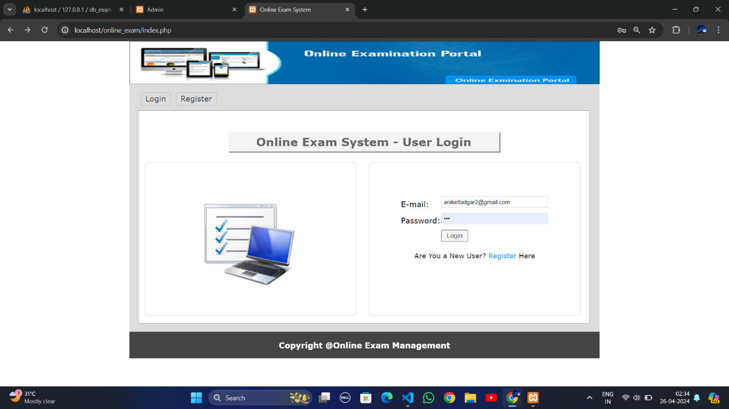**

**Sign up Page:**

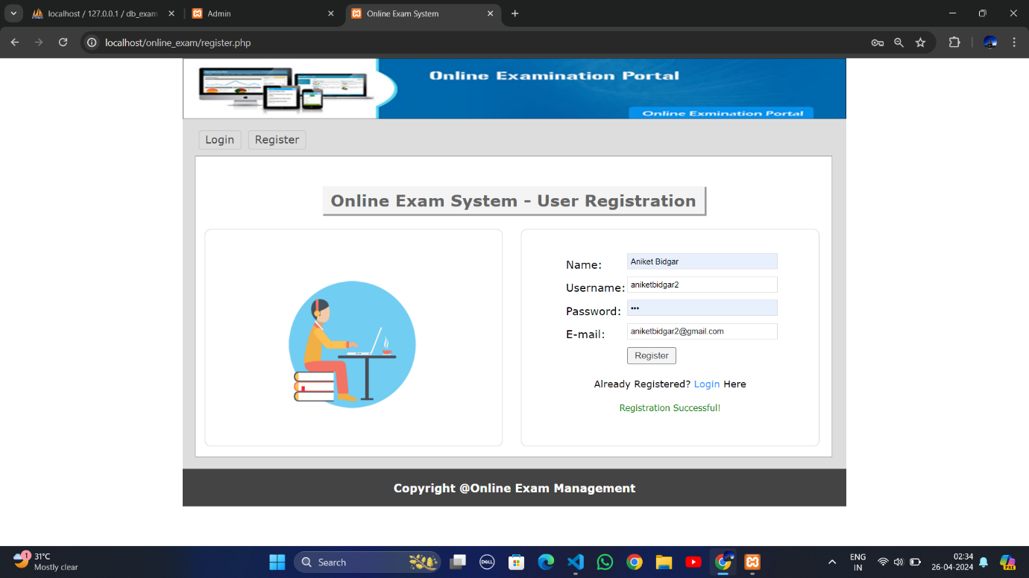

**Home Page:**

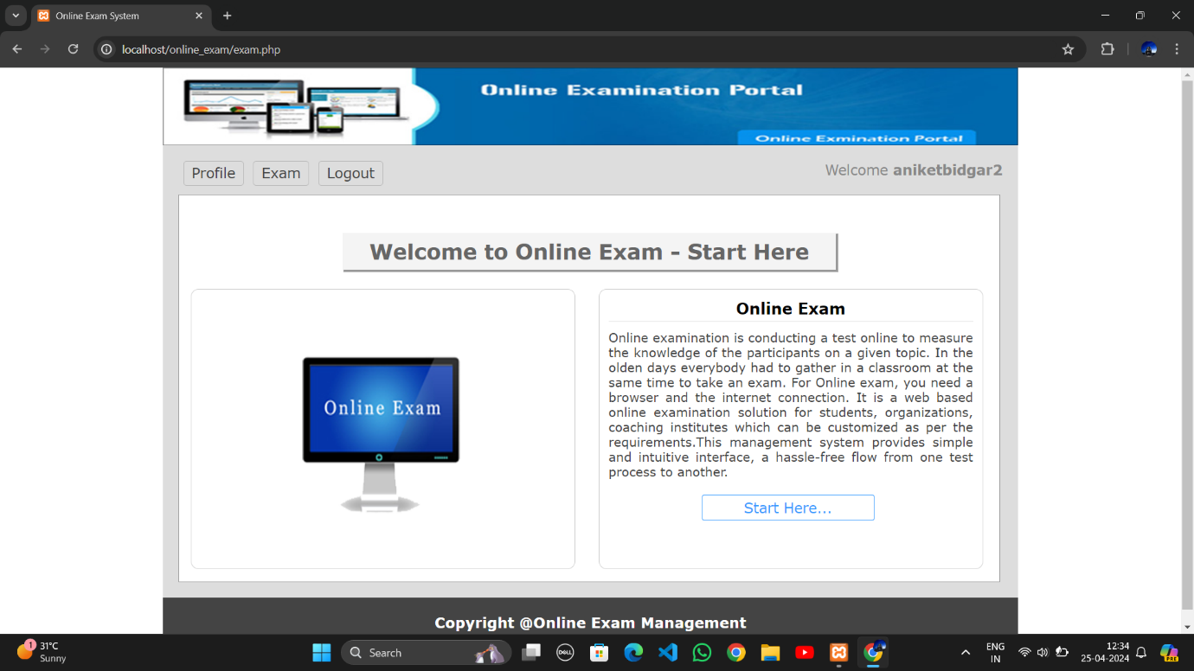

**Question Paper:**

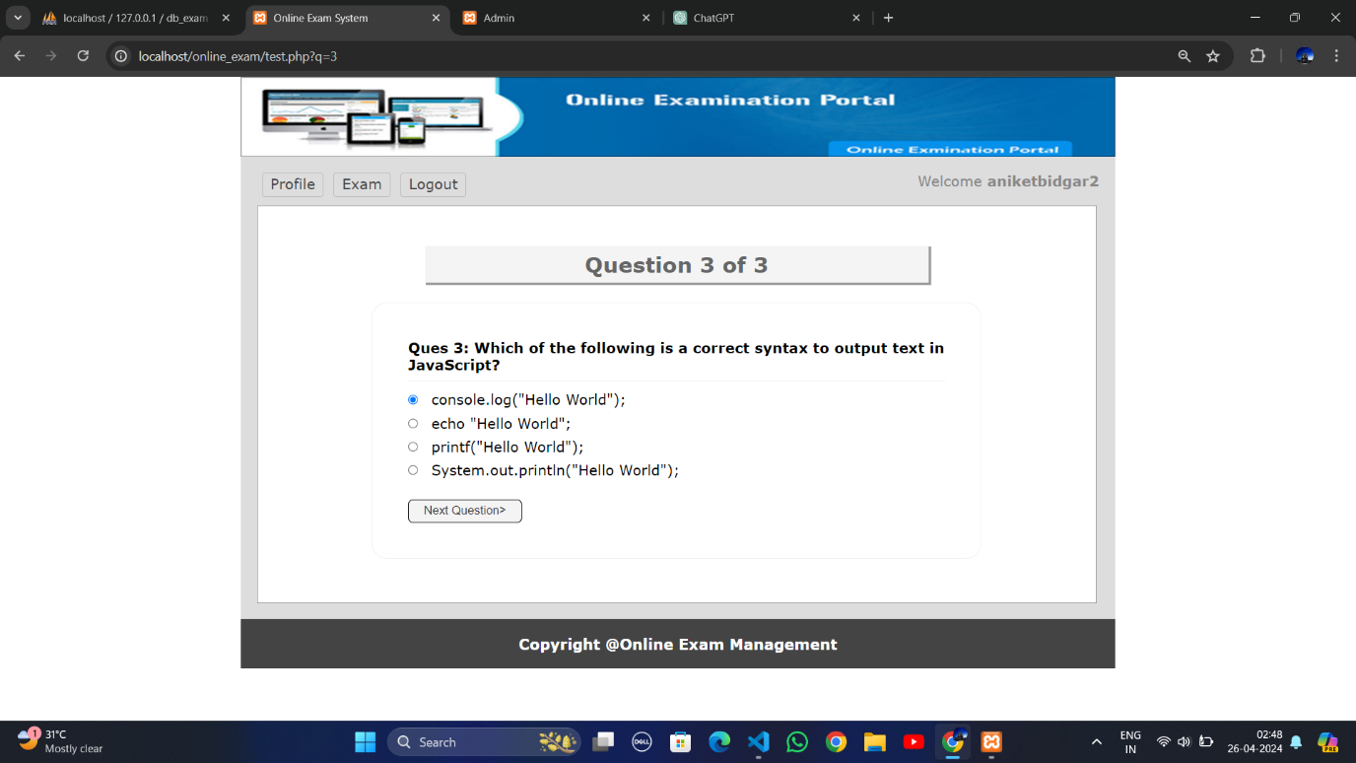

**Result and Viva Request:**

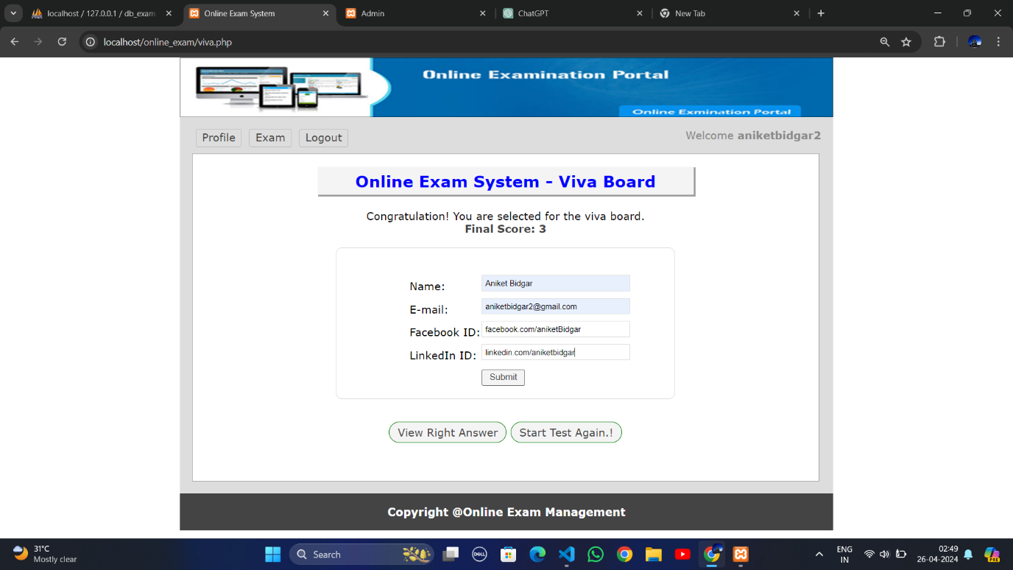

**Answers:**

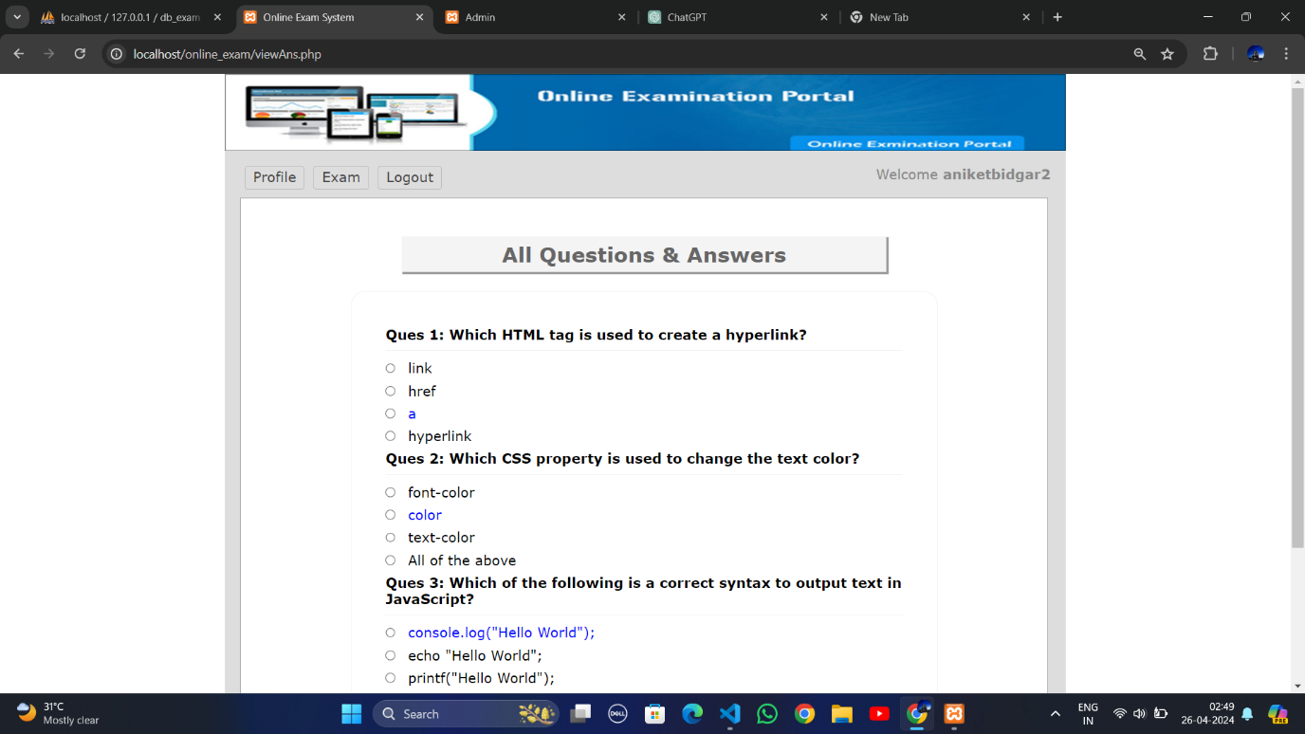

**Profile:**

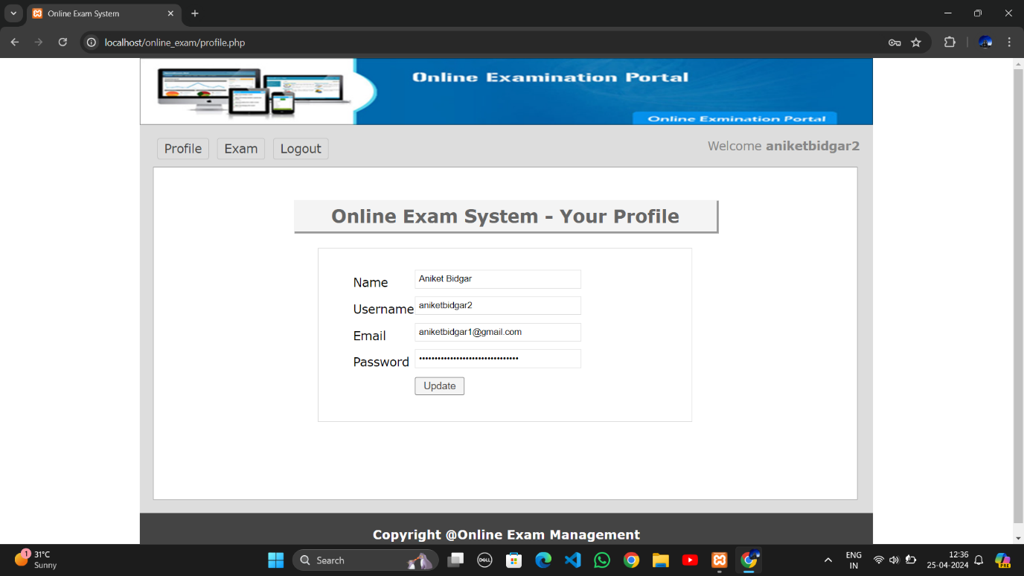

**Admin Login Page:**

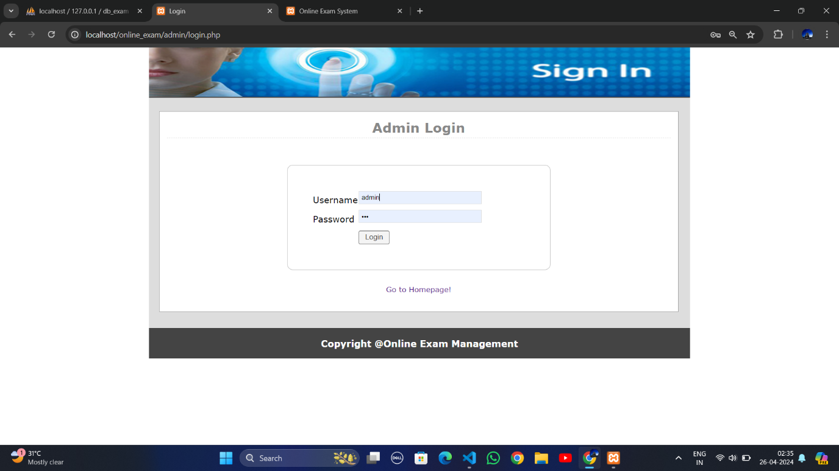

**Manage Users:**

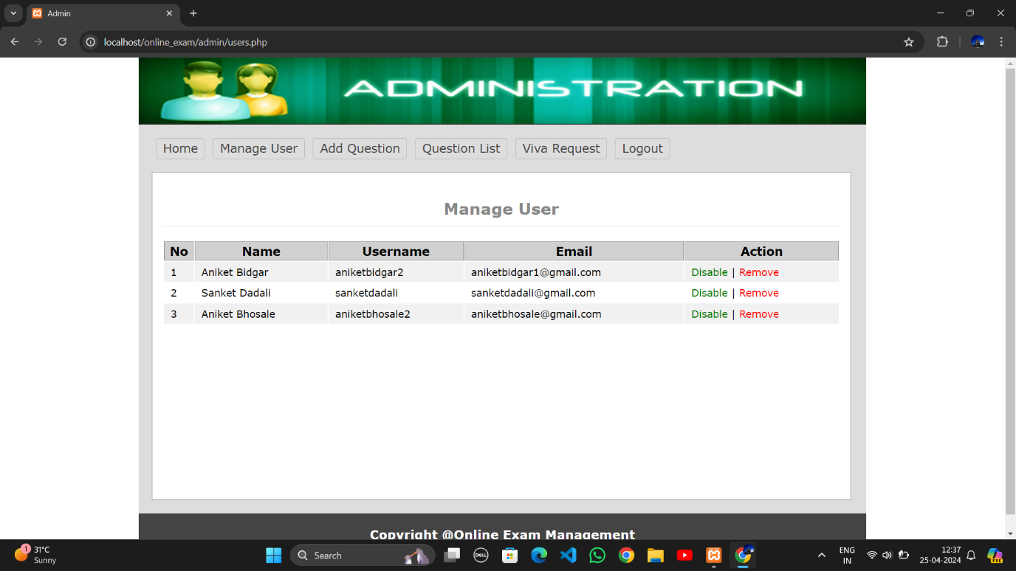

**Add Questions:**

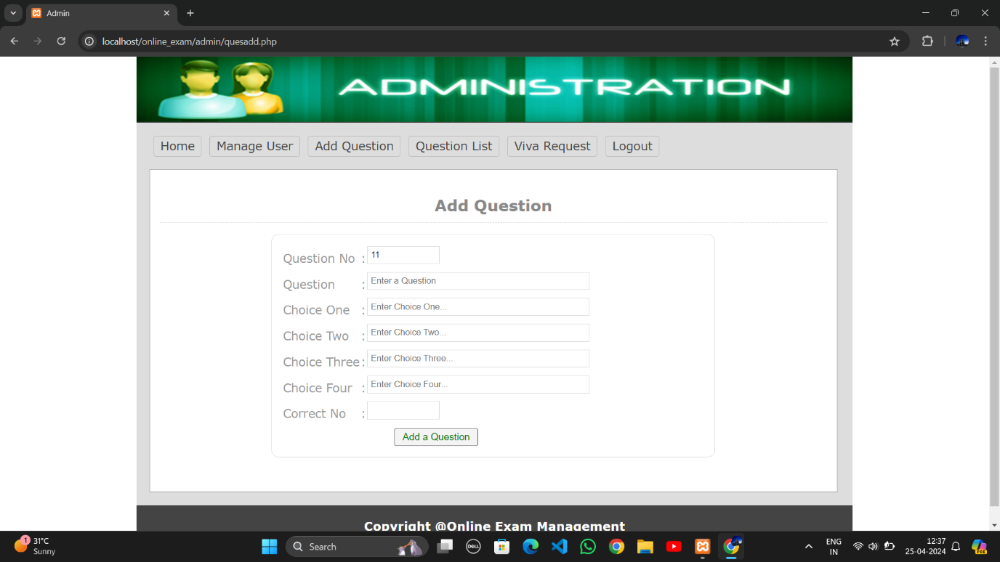

**Added Questions:**



**Viva Request Page:**

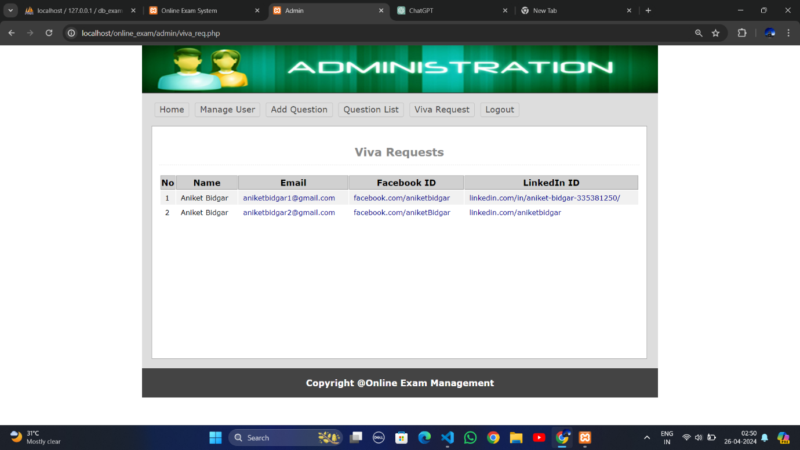

**IMPLEMENTATION**

1. Determine the Goals of the Online Exam System :

Define the specific objectives, such as providing a platform for online exams, instant results, user friendly interfaces for both admin and users, secure exam environments, and integration with learning management systems (LMS).

2. Choose an Appropriate Platform :

Select a platform that supports PHP, XML, HTML, CSS, and JavaScript, with a backend in SQL. Consider CMS platforms like WordPress with custom PHP based plugins, or frameworks like Laravel or Symfony for custom development.

3. Develop Exam Content :

Create a structure for exam content, including question types (multiple choice, true/false, short answer), and set up question banks. Use HTML, CSS, and JavaScript to build interactive and visually appealing exam pages.

4. Implement Exam Management Tools :

Develop an admin interface for managing exams, creating question papers, scheduling exams, and viewing results. Include features for user management and permissions to ensure security.

5. Incorporate Security Measures :

Implement security features to prevent cheating and maintain exam integrity. Use secure user authentication, monitor for unusual activity during exams, and integrate SSL/TLS for secure data transmission.

6. Develop Automated Result Processing :

Create scripts in PHP to automatically grade exams with simple question types, such as multiple choice. Implement logic for more complex grading and manual evaluation for essay type questions.

7. Include User and Admin Dashboards :

Design user friendly dashboards for users to take exams and view results, and for admins to create, manage, and analyze exams. Ensure dashboards are intuitive and responsive.

8. Integrate Interactive Features :

Add interactive features like online practice quizzes, feedback forms, and exam related discussion forums to enhance user engagement and learning.

9. Incorporate SEO for the Exam System Website :

Use SEO techniques to improve the visibility of the online exam system website on search engines. Include relevant keywords, meta descriptions, and structured data to optimize for search.

10. Develop Testing and Quality Assurance :

Implement thorough testing, including user testing, to ensure the system is easy to navigate and functions smoothly. Perform security testing to identify and resolve vulnerabilities.

11. Incorporate Social Media Integration :

Integrate social media sharing options for users to share exam related achievements or information. This can help with system promotion and user engagement.

12. Include References and Resources :

Provide helpful resources for users and admins, such as guides for using the system, exam policies, and support contact information.

13. Test and Deploy :

Conduct comprehensive testing before deployment. Deploy the system on a reliable web server, and set up monitoring to ensure high availability and quick response to any issues.

These steps provide a comprehensive implementation guide for developing an online exam system using PHP, XML, HTML, CSS, JS, and SQL as the database.

**Online Exam System**

Online exams have gained prominence as a convenient alternative to traditional in-person exams, offering flexibility, instant results, and reduced logistical challenges. However, there are various factors that can affect the adoption and effective implementation of online exam systems, particularly within academic institutions and professional organizations. This research project aims to explore the key factors that influence the successful adoption of online exam systems.

The objective of this research project is to identify the factors that impact the successful adoption and implementation of online exam systems. Specifically, the project aims to:

1. Examine the usability and user experience for both students and administrators, focusing on the ease of use and accessibility of the online exam system.

2. Identify technical challenges, such as compatibility with different devices and operating systems, network reliability, and data security.

3. Determine the measures needed to ensure exam integrity, including anti-cheating mechanisms, secure authentication, and identity verification.

4. Assess the ability to deliver instant results and automated grading, and understand the limitations of automated grading for complex question types.

5. Evaluate the cost implications for institutions, including software licenses, server infrastructure, and maintenance costs.

6. Analyse the flexibility and scalability of the online exam system, particularly in terms of accommodating a large number of users and supporting diverse exam formats.

**FUNCTIONALITIES AND ADVANTAGES**

**Functionalities of an Online Exam System:**

1. Online Exam Creation : Administrators can create exam papers by defining questions, answers, and grading schemes. Question types can range from multiple-choice to essay, allowing for a wide variety of exam formats.

2. User Management : The system enables administrators to manage users, including adding students, creating user roles (like examiners and students), and setting access levels. This functionality allows examiners to assign exams and monitor student progress.

3. Automated Grading : For certain question types, such as multiple-choice or true/false questions, the system can automatically grade student responses, providing immediate feedback and results.

4. Secure Authentication : The system uses secure authentication methods to ensure that only authorized users can access the exam. This includes login protocols, identity verification, and anti-cheating measures.

5. Timed Exams and Access Control : Administrators can set specific time limits for exams and control when exams are available for students to take. This ensures fairness and prevents unauthorized access to exam content.

6. Real-Time Monitoring and Proctoring : The system can include features for real-time monitoring, allowing examiners to observe exam takers during the test. This can help prevent cheating and ensure exam integrity.

7. Integration with Learning Management Systems (LMS) : The online exam system can integrate with existing LMS platforms, enabling seamless user management, grade synchronization, and shared resources.

8. Instant Results and Reporting : The system provides instant results for automatically graded questions and generates comprehensive reports for administrators to review. This feature allows for quick assessment and feedback.

**Advantages of an Online Exam System:**

1. Flexibility and Convenience : Online exam systems allow students to take exams from any location, providing flexibility and reducing logistical challenges associated with traditional exams.

2. Cost-Effectiveness : Online exams eliminate the need for physical exam spaces, printing materials, and other costs associated with traditional exams. This can lead to significant cost savings for educational institutions.

3. Reduced Environmental Impact : By eliminating the need for paper-based exams, online exam systems contribute to a reduction in paper usage, promoting a more sustainable approach to testing.

4. Faster Feedback and Results : The automated grading features of online exam systems enable immediate feedback for students and faster grading for examiners, improving the overall efficiency of the assessment process.

5. Improved Security and Integrity : Online exam systems offer secure authentication methods and anti-cheating measures, such as real-time proctoring and lockdown browsers, ensuring exam integrity.

6. Scalability and Accessibility : Online exam systems can accommodate a large number of users and support various exam formats. This scalability makes it easier for institutions to conduct large-scale exams without logistical constraints.

7. Data Analytics and Insights : The system's reporting features provide valuable data on student performance, allowing educators to analyze results and gain insights into student learning trends.

8. Reduced Administrative Burden : With automated grading and streamlined user management, online exam systems reduce the administrative burden on examiners, allowing them to focus on other teaching and assessment tasks.

**CONCLUSION**

In conclusion, the feasibility study demonstrates that implementing an online exam system can significantly benefit educational institutions and other organizations conducting assessments. This project showcases the efficiency, flexibility, and convenience that online exams provide, along with their positive impact on the environment due to reduced paper usage.

The study highlights the importance of robust security measures and user-friendly interfaces to ensure a smooth and secure online examination experience. Additionally, it identifies key challenges such as maintaining exam integrity, addressing technical issues, and ensuring access for all users. The project provides recommendations to address these challenges, emphasizing the need for reliable technology infrastructure, secure authentication protocols, and effective proctoring techniques to uphold exam integrity.

Overall, this study indicates that online exam systems have the potential to streamline examination processes, reduce administrative overhead, and provide instant results, thereby enhancing the overall assessment experience. With careful planning and appropriate safeguards, educational institutions and organizations can successfully implement online exam systems to meet the needs of a modern, digital world.

**References**

<https://www.w3schools.com/html>

<https://www.w3schools.com/css>

<https://www.w3schools.com/javascript>

<https://www.w3schools.com/php>

<https://www.javatpoint.com/xampp>

<https://www.guru99.com/xampp>

<https://jquery.com/>.

<https://www.php.net/manual/en/index.php>.

<https://dev.mysql.com/doc/>.